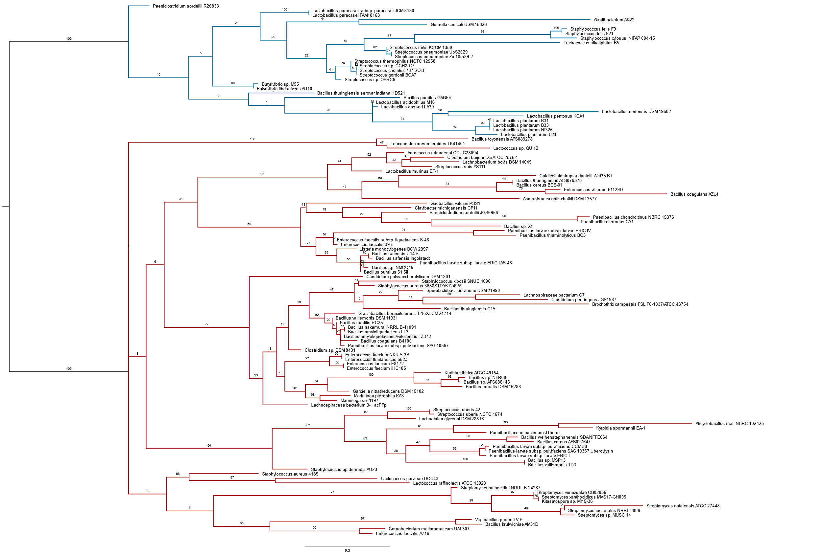
Figure S2: Phylogenetic tree showing the two subfamilies of circular bacteriocins. Subfamily IIc i is shown in red, while IIc ii is shown in blue.

